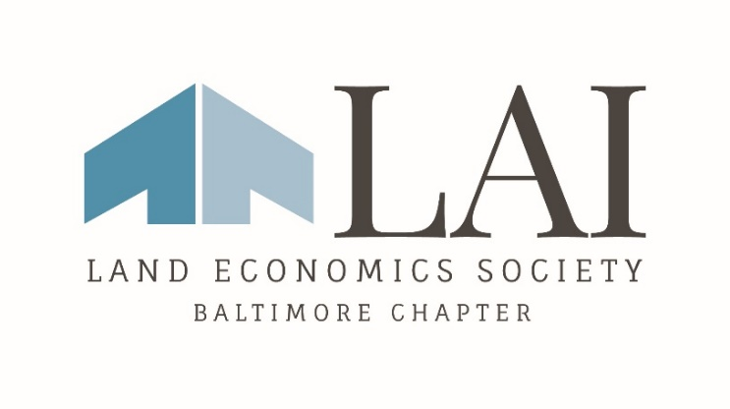
2023 Membership Program Meeting Schedule
Monthly Lunch Program meetings are held at from 12:00 p.m. to 1:30 p.m.
January 18
February 15
March 15
April 19
May 17
June 21
July 19 – Summer Outing
September 20
October 18
November 15– Annual Dinner Meeting
Board Meeting Schedule
Quarterly Board Meetings are held from 2:00 p.m. to 3:00 p.m.
January 24
March 28
May 23
July 25
September 26
November 7

